Steps To Deploy App to Apple AppStore

“Note : Make sure you have a Mac and Make sure you sign for apple developer that means you must have an Apple Developer ID.”

Let me clear this documentation is for flutter only.

To Deploy App in AppStore follow this steps:

Step1:

Create a Flutter App

Step2:

“ Note : make sure there is no error in the project and test it well”

After completing the project open terminal in your IDE

And Enter this command: “ flutter build ios”

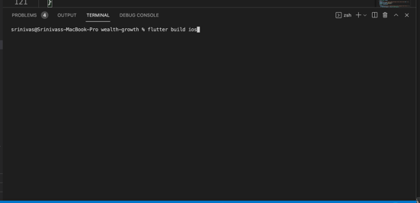

Then flutter will build file for xcode.

After building the file open xcworkspace in xcode

Step3:

In Xcode open Product section in nav bar there you will find archive

Click on archive to generate IPA

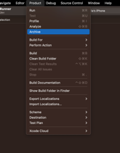

There will create an IPA file and store in archive .

Step4:

In Archive there click on distributed button and follow some actions

Like click on next until you find upload button

Click on Upload button it will take some time to upload the IPA to your apple dev

account . after upload done . goto the apple app store

Step 5 :

In Apple app store to go account

There you find this kind of interface . simply click on apps

And you will be directed to the application

Step 6 :

Click on the app you want to deploy and fill entire fields

Such as

After entering the entire fields click on add for review button

This will take upto 2-3 days to review once it pass the review it will uploaded to app store

“Note : make sure to update version in pubscep.yml

“

Steps To Deploy App to Google play Store

Step1 : Create ABD file from your project

Step 2: Login in google play console

Step3: Create a new app and fill entire field

Step4 upload your ABD file

Step5 : send it to review

Step 6: change mode to production